Summer Conversational Series
TUESDAY, JULY 18, 2017

Cathlin Davis "From Story to Action: Social Justice in Louisa May Alcott's Fiction"
Social justice: common sense vs. the common good -- especially true in Louisa's works
This quote provided by Dr. Davis sums up Louisa’s feelings about social justice and one of the purposes of her stories:
“It was a charity which appealed to all hearts when it was known; but in this busy world of ours, people have so many cares of their own that they are apt to forget the wants of others unless something brings these needs clearly before their eyes.” From “The Blind Lark” by Louisa May Alcott
Social justice usually focuses on racial issues but Louisa did not in her juvenile literature -- more about the classes (rich versus poor)
Men and dignity, women and the working wage, children helping the poor (charity fundraisers,) – typical in each story is the well-off character will have a moment of enlightenment.
Stories help put a face on the problem. Louisa's stories first build empathy in the reader and then moves the reader from empathy to planned actions.
They find mentors to help. They find courage in solidarity. Transcendental self improvement through giving to others. Individual action can make a difference.
To know, care and act -- Louisa's stories emphasize this.
LMA always encouraged action but hard to know how often it was carried out by her readers.
St. Nicholas Magazine did document an action by readers of LMA's stories to help birds.
Empathy builds bridges between cultures through universal life happenings
STORIES DISCUSSED:
May Flowers (A Garland for Girls, 1888)
"May Flowers" – the character is wishing she could do something but cannot think of how to begin. Knowledge of an issue is not enough -- action needed. First step in story is to acquire knowledge through reading. Girls gather in sewing circle. Louisa does not shy away from dark issues like alcoholism. Children more resilient than people think and are able to deal with such issues. Many practical solutions offered in "May Flowers." Alcott expands the circle and gives the girls education
Our Little Newsboy (Aunt Jo’s Scrap-Bag 1, 1872)
Builds empathy for the little boy through his matter-of-fact description of his hard life, plus sensory description of his appearance, etc.
LMA suggests very specific actions for her readers which are small and easy to carry out.
Her focus is on personal charity, making the solution easier to carry out
Solutions that are too large or too extreme overwhelm and individual and thus are usually rejected with no action at all being taken -- Louisa chose more practical solutions
My Girls (Aunt Jo’s Scrap-Bag 4, 1878)
Encouraging girls to seek careers
Keep actions private - left hand doesn't know what the right hand is doing
Sacrifices money put towards luxuries, gives to charity instead
Fighting to get an education and appreciates it
An Old Fashioned Girl
Polly, Trix and the poor -- Polly suggests that they pay their seamstresses better (thinking of poor Jane who needed work as a seamstress). Thinking of Jane, Polly sang a sad song about a woman committing suicide and the girls in the sewing circle react with empathy.
The narrative gives Polly the courage to act, to tell the girls about Jane.
Three of the girls continued to befriend Jane and help her out as a result
A hand up rather than a hand out -- working for wages
Beatrice's Goat by Page McBrier
A modern day example of a children's book that inspires empathy and action
Heifer Project International a good example of a charity that gets into practical giving -- also has a curriculum for schools and churches to teach children about charitable giving. It follows Louisa’s sequence perfectly (to know, care and act)
The Blind Lark (Lulu’s Library III, 1886)
Interest children in a charity for children so that they will learn to give
Awareness created through the open house through the school, empathy created through a concert
Story published a year before the Perkins School for the Blind opened -- was there a connection? A fundraising appeal? Published in 1886
My Red-Cap (Proverb Stories, 1882; first published in “The Sword and Pen,” first four issues, Dec. 1881)
Regarding veteran's affairs
Red-caps were often disabled veterans who helped other veterans
The idea was to inspire the creation of a veteran's hospital
Louisa wanted to establish in others the habit of continuous help rather than just one act This story is a direct fundraising appeal for the Soldier's Home in Chelsea -- still in operation

Gabrielle Donnelly "Bread, Roses, and One-Liners: Jokes and Feminism from Louisa May Alcott to Tina Fey"
Bread and Roses song - about garment workers - taken up as a slogan as a time
LMA uses flower imagery like in the above song
Symbolism of Bread and Roses and Louisa's writings:
- the bread is her message -- always plain
- the roses were her humor -- that's how she gets her message across
- the lecture and the laugh
feminism and humor - both have gone through dormant stages and growth stages
During Louisa’s time, other women wrote such stories:
- Kate Sanborn The Wit of Women
- Marietta Holley, My Opinions and Betsey Bobbet's
conversations between characters Samantha and Josiah Allen about suffrage: humorous and relentlessly logical arguments about women and voting
After getting the vote in the 1920, feminism seemed to go to sleep -- Maybe too much work to do anything beyond the home (Gabrielle spoke of her own mother with five children and few conveniences and how after 20 years finally got to read again).
Humorous novels during the 1950s -- These books were the first reawakening of feminism.
- Jean Carr Please Don't Eat the Daisies
- Erma Brombeck
- Betty McDonald (most known for creating Ma and Pa Kettle) The Egg and I - classic humorous account about her husband suddenly deciding to become a chicken farmer after having sold insurance -- humor carries subtext of "get me out of here." Read section about doing the laundry which was very hard work; divorced her chicken farmer husband, remarried and became an author.
By the 1960s the conveniences lessened the work but women became bored. Betty Frieden came along with The Feminist Mystique. Feminism during this period was grim, without humor, but got a lot done.
Discussion of women in comedy -- not at all complementary
- Lucille Ball -- a naughty child who needed to be disciplined by her husband (and ironically, Lucille Ball was one of the most powerful women in Hollywood)
- Bewitched -- Samantha --- household drudge
- Rowen and Martin’s Laugh-In - The "Sock it to me!" girl, Judy Carne – constantly humiliated by having cold water thrown on her -- bad example
- Lily Tomlin had a different fate -- opened doors for female comics in the 1980s
Several women comedians in the 1980s were gay but could not use their personal life in their standup routines – not acceptable.
- Ellen Degeneres came out as gay and put her career in jeopardy
Women comedians today are far more free to be who they really are in their comedy -- this is a real step forward for feminism and humor. Tina Fey’s memoir and her example of fellow Saturday Night Live castmate Amy Pohler
Interesting discussion afterwards as one of the regular attendees of the Series was (and still is) a standup comedienne who worked with many name acts in Las Vegas.

Michelle Bees and Jane Sciacca "The Alcotts at Hillside: Their Beliefs and Actions"
These two women work for the National Park Service at The Wayside (Jane has just retired)
MICHELLE - History of Wayside – the oldest part, Colonial-style was built in the late 1600s – owned by Samuel Whitney family - muster master for the Revolutionary War - 10 children in a 4 room home.
The Wayside is considered a witness house – because the occupants saw the troops for the Revolutionary War
Description of the house (painted white with a picket fence) by the British general giving the draft orders to the British troops of provisions
The Whitneys owned 2 slaves (one named Casey)
The Alcotts lived there from 1845-48 -- added to either end of the house - 8 acres across the street given by Emerson
Stairs where the girls playacted Pilgrim's Progress stairs lead to attic
Nathaniel Hawthorne and his family owned the home from 1852-1870
1853-1860, the Hawthornes moved to Liverpool where Hawthorne served under President Franklin Pierce; also lived in Italy
After 1860, tower second floor added
Hawthorne died in 1864
1882-1965 The Lothrops -- Harriet Lothrop pen name Margaret Sidney The Five Little Peppers
Margaret Lothrop taught at Stanford for many years and returned when her mother died, remained at the house and opened it up to tours -- the Lothrops appreciated the history of the home; Margaret gave private tours before selling it to the National Park Service in 1965 - originally recognized as a witness house, later recognized for the authors that lived there; and now also recognized as part of the Underground Railroad (thanks to Jane Sciacca’s work).
JANE - Underground Railroad; slaves there during the Revolutionary War (slavery legal at that time) at least one on the Underground Railroad at Hillside when the Alcotts lived there.
"Casey," the slave of Samuel Whitney is also mentioned in Thoreau's journals - George Mina told Thoreau the story of Casey and his escape - freed as a soldier after the war. Whitney's son had been tormenting him and that's why he left.
Tax records of 1771 lists him - 1780 enlisted in Continental Army at 37 out of Lancaster, MA
Died in 1822 - was a farmer, lived alone - 90 years old
Alcott Years:
Abba's inheritance from her father enabled them to buy the house -- set up as a trust to protect it from Bronson's debts -- Samuel May and Samuel Sewell were trustees.
Bronson had a garden across the street and planted fruit trees behind the house.
The Hawthornes lived at the Old Manse with then 1 year old daughter Una; Emersons nearby; Thoreau lived at Walden Pond a few months after the Alcotts moved in.
Louisa finally got a room of her own at age 13. Plays in the barn, Pilgrim’s Progress played out on the stairs and on the terraces.
Family post office set up.
The Hillside was where Louisa wrote her first book, Flower Fables for Ellen Emerson; Little Women part one set there.
Bronson essentially in exile there. Could not open a school.
Sylvester Graham diet, frequent bathing, clothes that did not bind movement.
Alcotts could not find acceptance except when it came to the abolitionist movement
A town women's group led the effort.
Samuel Hoar and his daughter Elizabeth formally protested the selling of free blacks as slaves
Family suffered poverty; brought in troubled children to bring in income. Abba desperate to make ends meet.
Anna went off to teach and Abba reached out to family and friends for handouts.
Abba became a matroness at a water cure in Maine but had to return. Family had to leave the home in 1848 to Boston.
December 1846-Jan. 1847 -- harbored a runaway slave on the Underground Railroad whom they dubbed “John.”
Abba’s ancestors -- Mays, Sewells, Quincys all abolitionists. Judge Samuel Sewell wrote the first treatise of the evils of slavery in 1700.
Before moving into Hillside, Texas admitted as 28th state; also war with Mexico -- both expanded slavery
Underground Railroad depended on secrecy yet the Alcotts did document their experience with a runaway slave. Alcotts would have been subject to a fine and a lawsuit if they were discovered.
Alcott documentation the only known existing description of harboring a slave.
The war with Mexico in 1846 may have accelerated the involvement of the Alcotts with the underground railroad.
Abba recorded it in her journal and wrote to her brother Samuel May.
"John" supported the Alcotts' boycotting of slave products.
Bronson also recorded in his journal.
19 slaves between 1846-47 came to MA -- many stayed. We don't know how "John" came to stay with the Alcotts -- might have been part of a Boston vigilance committee -- could have come from Maryland. "John" wanted to go to Canada, did not feel safe in MA. Maryland accounted for the majority of the runaways due to its location near the north.

Jason Giannetti "Concord's Transcendental Conscientious Objector"
Alcott's time was a turbulent time, like today.
NE Transcendentalists were always politically involved. Transcendentally aware via literature and Nature; politically aware and active.
Bronson actively participated in practical actions in abolition.
Many concerns about industrialization and its effect on humanity
Margaret Fuller saw Women's issues intersecting with many other core issues.
Transcendentalism showed true power of progress over inertia
Apathy today is an existential threat.
Need something beyond human laws to turn to - this is transcendental.
Nature, God and conscience had equal authority - come from the same source. Nature is the physical face of God
The conscience is like an antenna, tuned into the divine -- we must draw ever closer for a clear signal.
Conscience not enough as humans are inherently flawed
Malcolm X -- originally espoused violence but came around to believing the world was not so black and white after all.
The Star Thrower Loren Eiseley – (click on link to read original) used analogy (wrote his own verse) from this story
Which cause to dedicate oneself? Not unlike following a career -- can be related)
Listen to your heart -- which issue most resonates with me?
The speaker (Jason) is a lawyer, writer and philosopher, artist at heart - combining work, vocation and heart's bliss
We are the Transcendentalist Conscientious Objectors, imbued with the divine with the power to receive the message and the power to resist
Jason’s talk sparked a lengthy discussion of today’s political situation

Kristina West “Growing Tomorrow: A Transcendental Education”
(Note: my notes were lost on this wonderful presentation, eaten by my tablet!)
The gist of this talk was about Henry David Thoreau and Bronson Alcott’s approaches to educating the child. Thoreau’s was based on intimate relationships with children based on mutual respect and appreciation. Thoreau’s education techniques were very “hands on” including numerous outdoor field trips to learn from Nature. Thoreau sprinkled much fantasy through his walks with the children, the fruit of that being Louisa’s first book, Flower Fables, dedicated to Ellen Emerson.
Bronson’s technique also involved intimate relationships with children but his was based on the conversation. He had a gift (according to Frederick Llewellyn Willis, a boarder with the Alcotts for several years in his teens and twenties) for explaining complex thoughts in plain language that any child could understand. He had a magnetic personality that drew children to him. Willis, in his Alcott Memoirs (which can be found on archive.org) he describes specific instances where Bronson taught about fruit at the dinner table and how engaged he was in that conversation.
Louisa of course, wrote for children. Her methods were more practical but the legacy of the father lives through the daughter’s extraordinary writing career.
Included are handouts from the presentation (see next page)
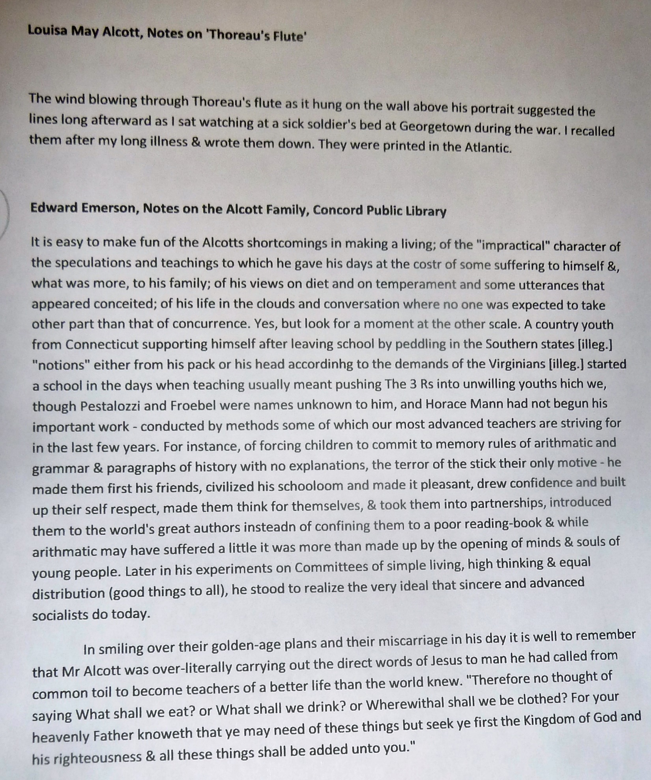

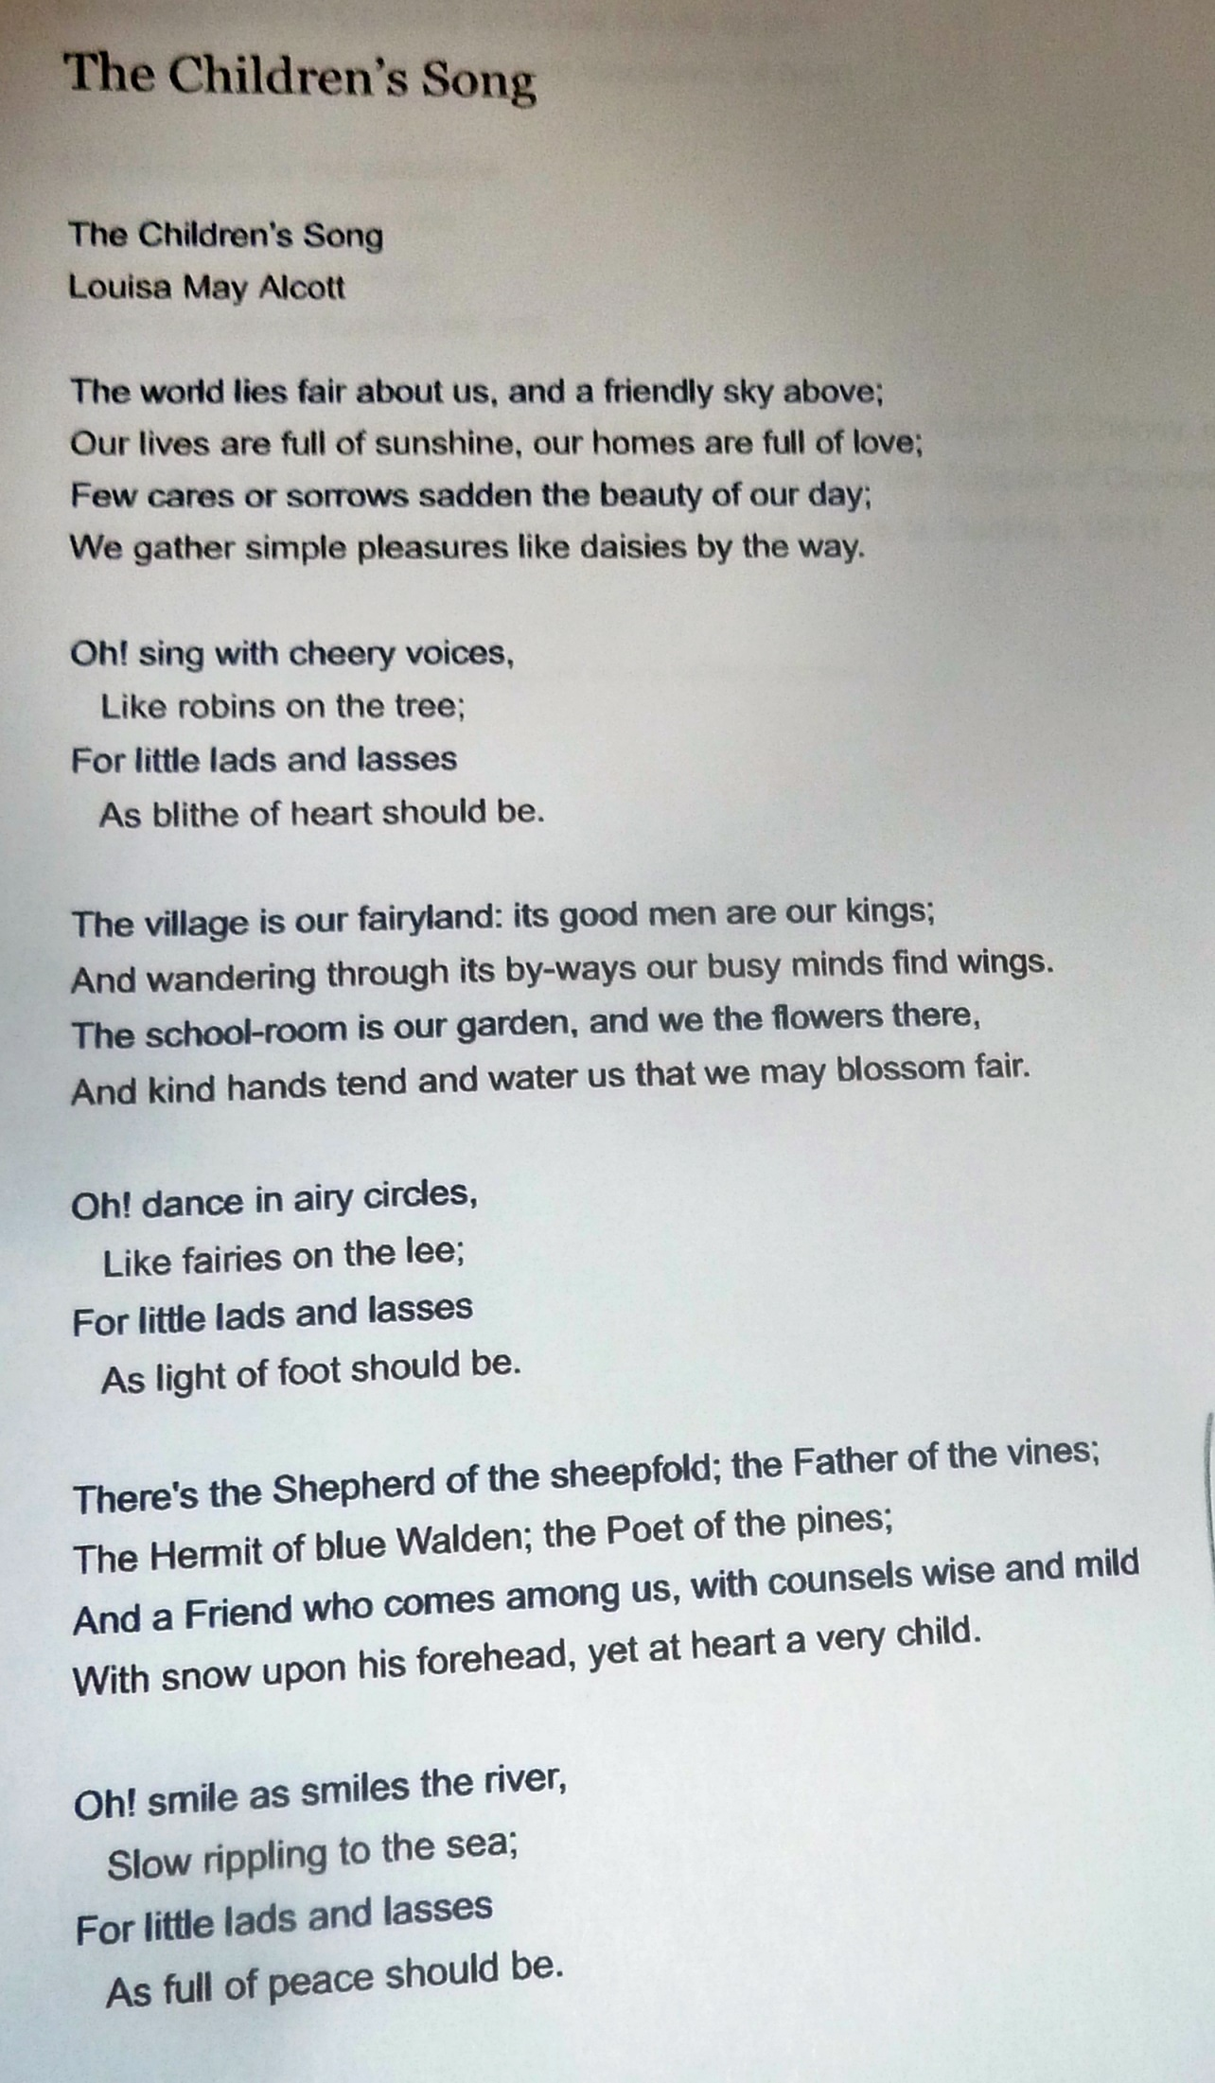
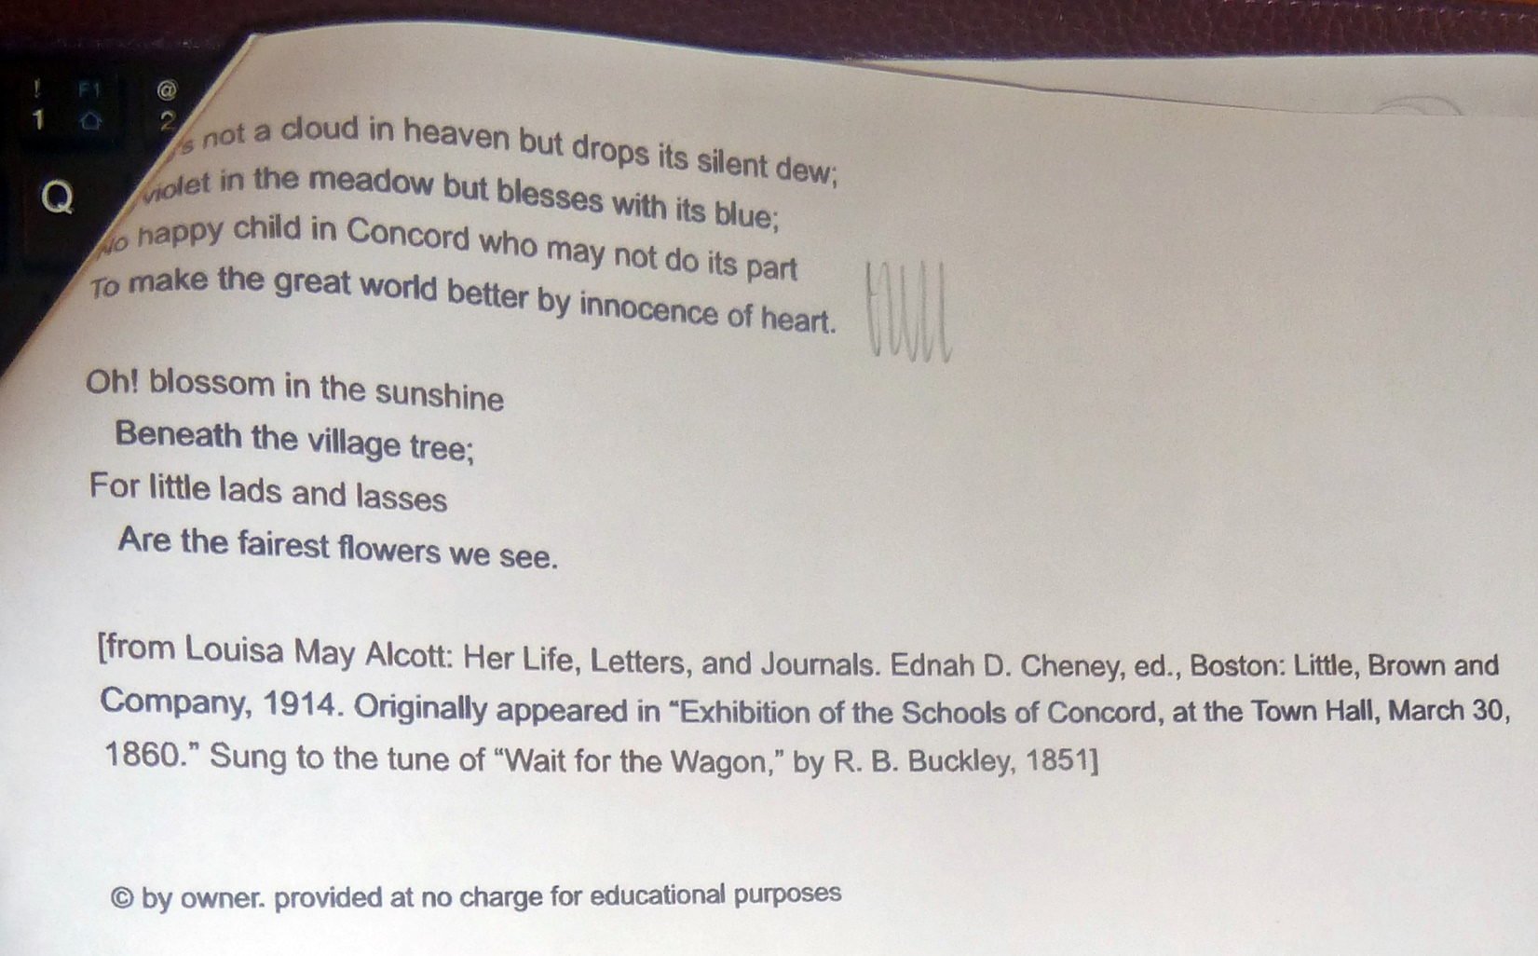

Jennifer Schünemann “Save the Mother, Save the Child: The Pandemic Exploitation of Women and Its Effect on the World”
(Note: yes, my evil tablet ate up these notes too! Such a fine presentation too. )
The best way to find out about this presentation is to visit the website of the organization that Jennifer works for: Durga Tree International:
About Jennifer http://durgatreeinternational.org/our-team/jennifer-schunemann/
About the organization http://durgatreeinternational.org/
About Project Bloom http://durgatreeinternational.org/our-work/bloom-program/

